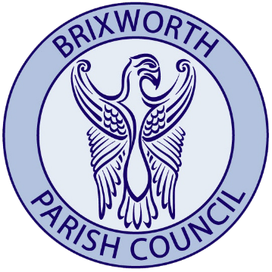

Grant Application Form

All questions on the Application Form must be fully answered. Additional information in support of an Application may be provided, where appropriate

- Organisation Details

Name:

Is it a registered charity: yes/no

Charity no.:
How many people use/attend your organisation?

How many are Brixworth residents?

Brief description of objectives of the organisation and activities in the parish:

- Contact Details
Name of contact: Address:

Postcode:
Telephone no.:
Email address:
Position of contact:
- Project / Activity Details

Briefly describe the project or purpose for which you require a grant (you must demonstrate a clear need):

How will the funding benefit residents of Brixworth (include the number of beneficiaries living in the Parish)?

- Financial Details

Current balance in all bank account (s) and investments at the time of this application

£

Estimated annual income and expenditure of organisation:

Income:

Expenditure:

What is the total cost of the project? £
What is the total amount of grant requested? £

Details of how the remaining balance will be funded:

Details of any fundraising events held / planned or funding received:

Details of previous grants from the Parish Council within the last 5 years:

Any other comments in support of your application?

- Declaration

I declare that I am authorised to make the application on behalf of the above organisation.

I have read and fully understood the Brixworth Parish Council Grants Policy and certify that the information contained in this application is correct at the time of submission.

Signed: ………………………………………………………………………………………………………..

Dated: …………………………………………...

Check – ü

- Read and understood the Grants Policy?

- Accounts attached?

- Constitution attached?

- Evidence attached of alternative funding sources (if applicable)?

- Evidence attached of the project costs?

- Evidence attached of ‘best value - three quotes for those projects costing more than £500?

Please return this form with enclosures to the Clerk of Brixworth Parish Council via email at
parish.clerk@brixworthparishcouncil.gov.uk

